OXIDATION-REDUCTION REACTIONS

Oxidation and reduction
- Apply the table of Standard Reductions Potentials to determine the relative strength of oxidising and reducing agents to predict reaction tendency
- Apply oxidation numbers to identify redox equations and/or oxidants and reductants
Identify by name and/or formula common oxidising and reducing agents including O₂, Cl₂, MnO₄⁻, Cr₂O₇²⁻, ClO⁻, H⁺, concentrated sulfuric acid, concentrated nitric acid and common reducing agents (reductants) including Zn, C, H₂, Fe²⁺, C₂O₄²⁻
- Describe and explain the role of the following in the operation of an electrochemical (galvanic) cell:
- Anode processes
- Cathode processes
- Electrolyte
- Salt bridge and ion migration
- Electron flow in external circuit
- Describe the electrical potential of a galvanic cell as the ability of a cell to produce an electric current
- Describe and explain how an electrochemical cell can be considered as two half-cells
- Describe the role of the hydrogen half-cell in the table of Standard Reduction Potentials
- Describe the limitations of Standard Reduction Potentials table

- Investigate a biological, environmental or industrial redox process applicable to context/s chosen e.g. metal extraction, commercial electrochemical cells, corrosion etc. Include:
- A description of the chosen process and the chemical reactions occurring
- An explanation of the relationships between the chosen process and the chemical models and theories
- Where appropriate
- Safe handling and disposal of any materials or specific chemicals involved in the process
- Discussion of the sustainability of the process
Discussion of the environmental impact of the process
OXIDATION – REDUCTION REACTIONS

These reactions are usually referred to as REDOX reactions.

Some important examples are:

the reactions of metals
respiration
photosynthesis
reactions in batteries
burning fuels
metal extractions
photographic developing
explosive reactions
corrosion of metals

In its simplest form OXIDATION may be regarded as the addition of oxygen to an element.

2Zn + O₂ → 2ZnO

If we examine the similar case of a reaction with sulfur

Zn + S → ZnS

then we see that in each case the change to the zinc is

Zn → Zn²⁺ + 2e

the zinc has LOST ELECTRONS.

(In the reactions of zinc, electrons must have been gained by some other species).

O + 2e → O²⁻

S + 2e → S²⁻

The simplest notion of REDUCTION becomes the removal of oxygen from a compound.

CuO + H₂ → Cu + H₂O

Or the gain of electrons by a species.

Cu²⁺ + 2e → Cu

A more useful definition of redox now becomes:

Oxidation – reduction reactions are those which involve the transfer of electrons.

Complete Review Exercise 9.1
The electron transfer process may be described by HALF-EQUATIONS as follows.

For the reaction
Zn + Cu²⁺ → Zn²⁺ Cu

The halves of the equation are:

Oxid’n Zn → Zn²⁺ + 2e (electron loss)

Red’n Cu²⁺ + 2e → Cu (electron gain)

Oxidation Number

We may best identify which species has been oxidised or reduced by considering changes to OXIDATION NUMBER

Fe → Fe²⁺ + 2e

Fe → Fe³⁺ + 3e

In each case the oxidation number of iron has increased. The iron has been oxidised as it has lost electrons. Loss of electrons leads to increase in oxidation number.

For the reaction:

Zn + Cu²⁺ → Zn²⁺ + Cu

Oxid’n Zn → Zn²⁺ + 2e

The oxid’n number of zinc has increased from 0 to 2+

and that of copper has decreased from 2+ to 0.

Red’n Cu²⁺ + 2e → Cu

Our final definition of redox becomes:

Oxidation is signified by an increase in oxidation number

Reduction is signified by a decrease in oxidation number

Rules for assigning oxidation numbers

1. The oxidation number of an element is 0.

2. The oxidation state of a simple ion is its valence.

3. In molecular compounds or in compound ions:

a) hydrogen is assumed to be +1 (in metal hydrides as -1)

b) oxygen is assumed to be -2 (in peroxides as -1)

c) the sum of the oxidation numbers of all atoms = the charge on the compound or ion.

Example

To find the oxidation number of sulfur in hydrogen sulfide (H₂S).

2 x (Ox No of H) + (Ox No of S) = 0
2 x 1 + (Ox No of S) = 0
2 x 1 + -2 = 0

Oxidation number of sulfur is -2

Complete Review Exercise 9.2 Questions 1 and 2

Questions on page 290 No: 1, 2 and 3

Some simple redox reactions

Metal/metal ion displacement

We have already seen that some metals are capable of displacing others from solutions of their ions.

Zn/Fe²⁺ Fe/Cu²⁺ Zn/Cu²⁺

all work to displace the less “powerful” metal.

Zn + Fe²⁺ → Zn²⁺ + Fe

This change may be regarded as two separate but associated changes.

Zn → Zn²⁺ + 2e oxidation half

Fe²⁺ + 2e → Fe reduction half

Write the half equations for the other displacements shown above.

Halogen/halide ion displacements work in a similar way.

Cl₂/Br⁻ Br₂/l⁻ Cl₂/l⁻

All work to displace the less “powerful” element.

Cl₂ + 2Br⁻ → 2Cl⁻ + Br₂

The associated changes are

Cl₂ + 2e → 2Cl⁻ reduction half

2Br⁻ → Br₂ + 2e oxidation half

Write half equations for the other displacements shown above.

Developing balanced redox equations
Not all redox reaction involve such simple substances but every redox reaction does involve the separate yet associated oxidation and reduction processes.
Each of these processes may be represented by a half equation.
We need to adopt a set procedure.

Consider a reaction in which Fe²⁺ ions are oxidised to Fe³⁺ by the addition of potassium permanganate solution. (The potassium ion is not involved)

Fe²⁺ → Fe³⁺
MnO₄⁻ → Mn²⁺

Step 1 balance for all except O and H

Fe²⁺ → Fe³⁺
MnO₄⁻ → Mn²⁺

Step 2 balance for O by adding water

MnO₄⁻ → Mn²⁺ + 4H₂O

Step 3 balance for H by adding H+ ions

MnO₄⁻ + 8H⁺ → Mn²⁺ + 4H₂O

Step 4 balance for charge by adding electrons

Fe²⁺ → Fe³⁺ + e
MnO₄⁻ + 8H⁺ + 5e → Mn²⁺ + 4H₂O

Step 5 make the number of electrons in each half equation equal

5Fe²⁺ → 5Fe³⁺ + 5e
MnO₄⁻ + 8H⁺ + 5e → Mn²⁺ + 4H₂O

Step 6 add equations

5Fe²⁺ → 5Fe³⁺ + 5e
MnO₄⁻ + 8H⁺ + 5e → Mn²⁺ + 4H₂O
5Fe²⁺ + MnO₄⁻ + 8H⁺ → 5Fe³⁺ + Mn²⁺ + 4H₂O

The balanced redox equation

Try these

Concentrated nitric acid reacts with copper metal to produce the gas NO₂ and Cu²⁺ ions

Cu → Cu²⁺
HNO₃ → NO₂

- Write the balanced redox equation.

- How about this one?

The dichromate ion Cr₂O₇²⁻ oxidises hydrogen peroxide H₂O₂ to oxygen. The other product is the Cr³⁺ ion.

Review Exercise 9.2 qu 3, 4 and 5

Questions page 291 qu: 4, 5, 6, 7
STAWA Exp’t 17 and 18

With halide ions

MnO₄⁻ + Br → Mn²⁺ + Br₂

- Develop the half equations and hence the balanced overall redox equation.

- Describe your observations and account for the colour changes.

Cr₂O₇²⁻ + 1⁻ → Cr³⁺ + I₂

- Develop the half equations and hence the balanced overall redox equation.

- Describe your observations and account for the colour changes.

With hydrogen peroxide

MnO₄⁻ + H₂O₂ → Mn²⁺ + O₂
Cr₂O₇²⁻ + H₂O₂ → Cr³⁺ + O₂

- Develop the half equations and hence the balanced overall redox equations for these reactions.

- Describe your observations and account for the colour changes.

Will iron II sulphate

MnO₄⁻ + Fe²⁺ → Mn²⁺ + Fe³⁺

Cr₂O₇²⁻ + Fe²⁺ → Cr³⁺ + Fe³⁺

- Develop the half equations and hence the balanced overall redox equations for these reactions.

- Describe your observations and account for the colour changes.

Acidifying the solutions

In your experiment you needed to acidify the oxidising agents for the reactions to work. In the equations that you have developed on the preceding pages the H⁺ is a reactant in every case. The permanganate and dichromate ions are good and useful oxidising agents in acidic solution. The solutions are oxidised with sulphuric acid.
SO₄²- cannot be oxidised.

- Why not?

Hydrochloric acid cannot be used as CI- is readily oxidised to form chlorine gas CI₂

- Write the equations for the oxidation of chloride ion by permanganate and dichromate ions.
The reaction consumes oxidant and interferes with quantitative results when MnO⁴⁻ and Cr₂O₇²⁻ are used in volumetric analysis.

The reactivity of the chloride ion with oxidising agents provides a useful means of preparing chlorine gas in the laboratory.

Either:

Conc HCI is added to cold KMnO₄

Or

Conc HCI is added to hot MnO₂

- Write half equations and develop balanced redox equations for these reactions.
Nitric acid as an oxidising agent

Unreactive metals like copper and silver do not react with sulphuric or hydrochloric acids as they are not powerful enough to reduce the H⁺ ions.

With dilute nitric acid

Cu + NO₃- → Cu²⁺ + NO

With concentrated nitric acid

Cu + NO₃⁻ → Cu²⁺ + NO₂

- Develop the half equations and hence the balanced overall redox equations for these reactions.

- Describe your observations and account for the colour changes.
Volumetric Analysis Using Redox Reactions

The technique of titration is extensively used in important commercial analyses.

The iron content of iron ore
Soil, air and water analyses
Chemical content of primary produce
Alcohol content of drinks
Preservatives in dried foods

Redox Titrations

These titrations are carried out in the same way as acid/base titrations. One solution is added to another until the equivalence point is reached.
- What is meant by “equivalence point”?

One main difference is that indicators are not required as the reactants change colour at the equivalence point.
For example, KMnO₄ changes from purple to colourless (very pale pink).

Calculations based on redox titrations follow the same method as for acid/base titrations. A typical analysis might be to determine the exact concentration of an approx 0.1 mol L⁻¹ solution of KMnO₄.

A primary standard must first be prepared.

- Find the names of 3 suitable standards

- Why are they suitable? (4 reasons)

Before we start the titrations we are going to work some sample calculations.

- STAWA Set 20

Electrochemical Cells and Standard Reduction Potentials

Redox reactions are essentially simultaneous half reactions that depend on each other. They are electron transfer reactions.

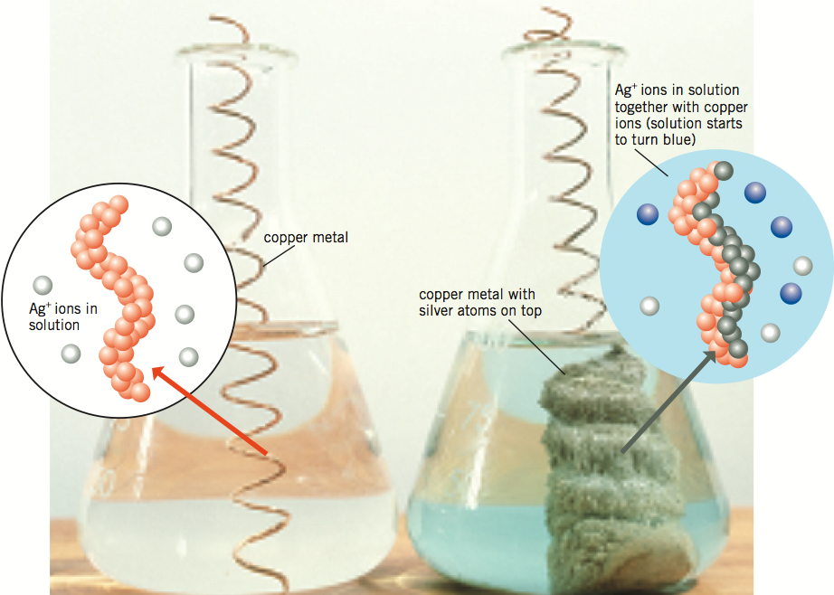

If we separate the reduction and oxidation halves into different containers perhaps we can use the reaction to generate an electric current.

Try to design apparatus that could achieve this.
Identify the site of oxidation, the site of reduction, the means of charge transfer.

Electrochemical Cells

These cells consist of 2 half-cells (couples) each containing a reactant with its redox product.
Eg. Cu in Cu²⁺ ions, Zn in Zn²⁺ ions may be written as Zn/Zn²⁺//CU/Cu²⁺
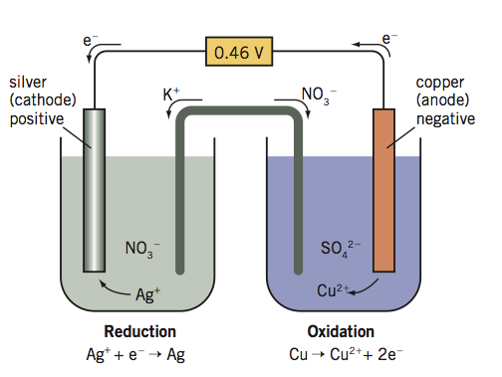

The voltage (cell potential, emf) of the cell is the difference in the potentials of the couples. These values have been tabled as a comparison with a standard hydrogen half-cell assigned the value 0.00 Volts.

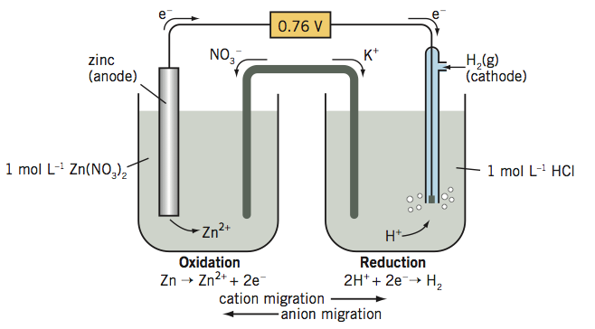

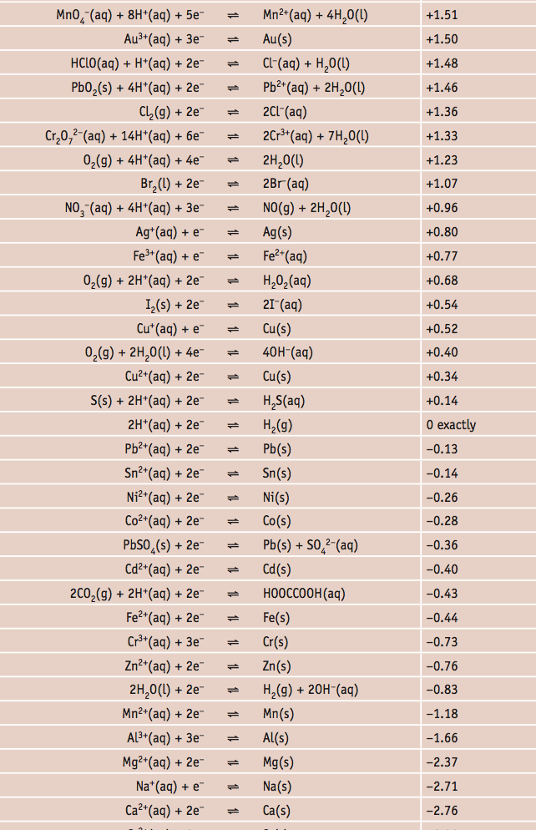

Calculating cell voltage

To calculate cell voltage write the appropriate half-cell equations and their Eº values. (The equation listed lowest in the table shos the species most easily oxidised and hence the site of the oxidation in the cell and should be written as an oxidation).

Zn → Zn²⁺ + 2e⁻ Eº = + 0.76 V
Cu²⁺ + 2e⁻ → Cu Eº = + 0.34 V

Zn + Cu²⁺ → Zn²⁺ + Cu Eº = + 1.10 V

Review exercise 9.3 questions 1, 2 and 4
9.4 questions 1, 2 and 4

Questions and problems page 291 questions 8 to 14

STAWA EXPT 14
Predicting Reaction Tendency

Redox reactions like metal displacement, halogen displacement, and acid reactions may be predicted by considering Eº values.

When reactants are directly mixed and the calculated cell emf has a positive value the reaction will proceed provided the activation energy barrier is not too high for the conditions.

e.g. Will magnesium dissolve in a solution of Fe²⁺ ions?

Mg + Fe²⁺ → Mg²⁺ + Fe?

Mg → Mg²⁺ + 2e⁻ Eº = + 2.36V

Fe²⁺ + 2e⁻ → Fe Eº = - 0.46V

Overall the cell emf is + 1.92 V
The reaction will proceed

- Will silver dissolve in zinc nitrate solution?

- Will these metals react with cold water?

potassium sodium calcium magnesium iron

- Review exercise 9.5 questions 1, 2 and 3
- Questions and problems page 295 questions 22 to 25

Commercial Cells

The principles of the electrochemical cell are employed in the manufacture of commercial cells like dry cells, car batteries and “button cells” and fuel cells.

For each of these cells

- Draw a diagram to show their main components
- Write equations to describe the anode and cathode reactions
- Calculate the cell emf
- Describe the main advantages and disadvantages of their use
- Explain the major difference that exists between them



Dry Cell and button cell (same principles)

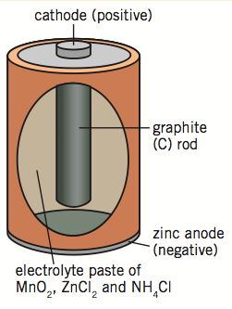

Car battery

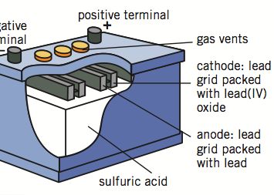

Fuel Cell

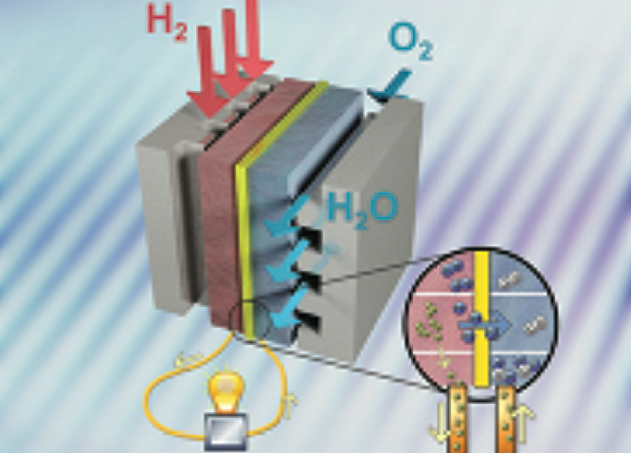

Any other cell of your choice

Review exercise 10.1 questions 1, 2, 3 and 5
Page 310 questions 2, 3, 4, 5, 9
Corrosion

The oxidation of metals by substances in the surroundings

Why is a knowledge of corrosion so important?

Corroded metals: have poor mechanical strength
have poor electrical conductivity
occupy a larger volume than their uncorroded parent metals.

For corrosion of metals to occur water and oxygen must be present as they are reactants in the process. (Although the presence of salt in moist air accelerates the process the salt is not essential for corrosion to occur)

The most common form of metal corrosion, that of iron, is called rusting.

The rusting process follows the following steps

Iron is oxidised

Fe → Fe²⁺ + 2e

The surroundings (moist air) are reduced

O₂ + 2H₂O + 4e → 4OH⁻

Association of the redox products produces the substance that we call rust.

Fe²⁺ + 2OH⁻ → Fe(OH)₂

Subsequent oxidation occurs

4Fe(OH)₂ + O₂ + 2H₂O → 4Fe(OH)₃
(also written as Fe₂O₃.3H₂o)

This unstable compound dehydrates

Fe₂O₃.3H₂O → Fe₂O₃.H₂O

The commonly accepted formula for rust

STAWA Experiments

The electrochemical nature of corrosion

The accelerating effect of salt on the rusting process gives us some evidence of the fact that rusting is an electrochemical process (transfer of electrons and ions to create an electrochemical cell).

- Why?

Corrosion may be compared with an electrochemical cell by consideration of the following features anode reaction

cathode reaction
electron transfer through an external circuit
completion of the circuit by movement of ions through an electrolyte
measurement (or calculation) of an emf

- A model corrosion cell

Reactive metals corrode in this way if left in a moist aerated environment.

On your diagram label:

anode (site of oxidation), cathode (site of reduction), direction of electron flow, direction of ion flow

Write an equation for the rusting process

equ’n equ’n
Factors accelerating corrosion

Corrosion may be enhanced by some specific circumstances such as:

deformation of the object
differential availability of oxygen
contact with other metal objects

- Deformation

Example 1
Example 2
Most rust found
Explanation

- Availability of oxygen

Example 1
Example 2
Most rust found
Explanation

- Contact with other metals

Example 1
Example 2
Most rust found
Explanation (this screams for a diagram!)

Corrosion Protection

We can prevent, or at least slow down, corrosion by several methods.

Passive – painting, coating etc
Active – galvanising etc
Applied emf

- Describe, using examples, how each of these methods works

Modification of the environment

Modification of the iron

Passive corrosion protection

Active (sacrificial) corrosion protection

Applied emf (cathodic protection)

Galvanising – a special case

Galvanising (zinc coating) provides both active and passive protection. The coating, whilst coherent, prevents contact with moist air but becomes active (sacrificial) when scratched or chipped. Zinc and iron in the presence of moist air become an electrochemical cell with the zinc acting as the anode.

- STAWA experiment
- Review exercise 10.2 questions 1, 2 and 3
- Questions and problems page 310 questions 11, 12 and 15
CHEM 12 - REDOX Review TASK 1

- Give the oxidation number for chlorine in each of the following species:

OC1⁻ , C1O₄⁻ , HC1 , MgC1₂ , OC1₂ , HOC1 , HC10₃ , C1₂

- Give the oxidation number for phosphorus in each of the following species:

PH₃ , PO₄³⁻ , P₂O₅ , HPO₄²⁻ , P₄ , Mg₃P₂ , PO₃³⁻ , H₂PO₄-

- For each of the following changes construct the balanced half equation AND state whether it represents oxidation or reduction.

- SO₄²⁻  S (b) MnO₂  Mn²⁺
- IO₃⁻  I₂ (d) VO₃⁻  VO²⁺

- Balance the following redox equations by first writing the appropriate oxidation and reduction half-equations.

- Au³⁺ + Cu  Au + Cu²⁺

- Al + Cl₂  Al³⁺ + Cl⁻

- Cu + No₃⁻  Cu²⁺ + NO

- Cr₂0₇²⁻ + Fe²⁺  Cr³⁺ + Fe³⁺

- SO₂ + MnO₄⁻  SO₄²⁻ + Mn²⁺

- Cu₂O + H⁺  Cu + Cu²⁺ + H₂O

- XeO₃ + I⁻  Xe + I₂

- Using the information contained in the following descriptions, construct the appropriate half-equations and hence write the balanced overall equation for the redox reaction which occurs.

  - When a piece of copper metal is dipped into a solution of silver nitrate a pale blue solution forms and shiny silvery crystals cover the outside of the copper.

  - When chlorine gas is bubbled through a solution of sodium iodide a dark brown solid is formed.

  - When acidified dichromate solution is added to hydrogen peroxide a rapid reaction occurs in which a colour change from orange to green is observed. A colourless gas is also observed to form.

  - A piece of zinc metal dropped into concentrated nitric acid dissolves rapidly to form a colourless solution and a dark brown gas.

  - A test tube containing copper metal and concentrated sulphuric acid is heated strongly. A colourless gas with a pungent odour is detected and a pale blue solution is formed.

  - A sample of potassium permanganate when mixed with acidified iron (II) sulphate is rapidly decolourised leaving a pale yellow solution

  - A strip of Mg ribbon is added to a sample of dilute HNO₃, dissolving to form a colourless solution and a clear gas. The gas does NOT ignite when a lighted taper is placed near to it.
CHEM 12 - REDOX review TASK 2

- What is the concentration of a KI solution if 25.0 mL of it is completely oxidised by 16.80 mL of a 0.024 mol L⁻¹ KMnO₄ solution?

- If 15.0 mL of a FeSO₄ solution is oxidised by 21.3 mL of an acidified 0.015 mol L⁻¹ K₂Cr₂0₇, what is the concentration of the FeSO₄ solution?

- How many mLs of 0.050 mol L⁻¹ KMnO₄ solution are needed to oxidise 2.00 g of pure iron (II) sulphate in acidic solution?

- 0.50 g of impure iron wire was dissolved in acid to form a solution of Fe²⁺ ions. It is found that 18.5 mL of a 0.092 mol L⁻¹ KMnO₄ solution was needed to fully oxidise the Fe²⁺ solution. What is the % of iron in the wire?

- 1.40 g of impure oxalic acid (H₂C₂O₄) reacts fully with 26.04 mL of acidified 0.200 mol L⁻¹ KMnO₄. What is the % purity of the oxalic acid?

- A common hair bleach contains hydrogen peroxide (H₂O₂). 25.00 mL of bleach solution was diluted to 1.00 L with water and a 20.0 mL sample of this dilute solution was titrated against a 0.0204 mol L⁻¹ KMnO₄ solution, requiring 17.1 mL to reach the endpoint.

- Calculate (a) the concentration of H₂O₂ in the bleach solution
(b) the volume of strength of the bleach solution

- A solution of potassium chlorate (KC1O₃) was prepared by dissolving 0.62 g of impure solid in 250 ml. When 20.0 mL of this solution was titrated against a 0.106 mol L⁻¹ FeSO₄ it was found that an average volume of 22.6 mL of the iron solution was required to reach the endpoint.

What was the % purity of the original sample of KC10₃?

(Note ! ! C10₃⁻ is reduced to C1⁻ )

- 1.70 g of chromium-containing mineral is converted to an acidified dichromate solution, which required 50.0 mL of a 0.400 mol L⁻¹ iron (II) sulphate solution to reach an endpoint.

What was the % of chromium in the mineral?
Redox Equations and Calculations Revision

- For each of the following redox reactions write oxidation and reduction half equations and hence develop the overall equation. Give on observation for each reaction.

  - Magnesium metal with silver nitrate solution
Reduction
Oxidation
Overall
Observation

  - Dilute nitric acid with copper
Reduction
Oxidation
Overall
Observation

  - Concentrated sulphuric acid with zinc
Reduction
Oxidation
Overall
Observation

- Hydrogen peroxide solution was analysed with standard potassium dichromate solution. 25.0 mL of concentrated peroxide was diluted to 250.0 mL and a 20 mL sample required 23.65 mL of 0.0222 mol L⁻¹ dichromate solution for complete oxidation. Calculate the volume strength of the concentrated hydrogen peroxide.

- An 8.41 g sample of a mineral containing chromium was converted to 250 mL of a solution in which all of the original chromium was present as the dichromate ion a 25.0 mL sample of this solution required 24.8 mL of 0.415 mol L⁻¹ iron II sulphate to reach an endpoint.

- Write the overall balanced equation for this reaction.

- Calculate the number of moles of Fe²⁺ used in titration.

- Calculate the number of moles of dichromate used in each titration and hence the number of moles of chromium in the mineral sample.

- Calculate the mass of chromium in the mineral sample and hence the % purity of the mineral.

- Describe what you would see at the end point of the titration.

